|  |  |  |  |
| --- | --- | --- | --- |
|  | | | |
|  | **A**EIOU Framework | Group ID:3 | Sheet No: 1 |
| **Activity Sheet** | Group Name:She creates | |
| Project Title:Chip marketing app | |
| General Observation   * Design * Etching * Doping * Deposition * Testing * Packaging * Marketing | Sketch/Photo | |
| Special Notes   * Marketing * Design |

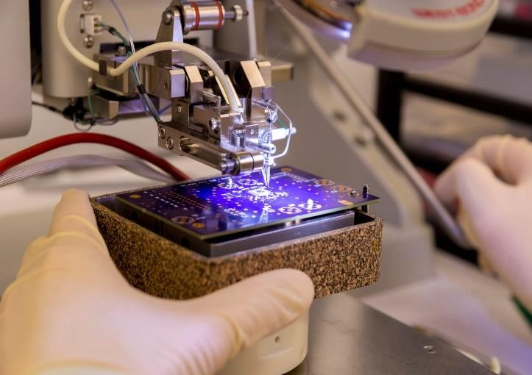

|  |  |  |  |
| --- | --- | --- | --- |
|  | | | |
|  | A**E**IOU Framework | Group ID:3 | Sheet No: 2 |
| **Environment Sheet** | Group Name:She creates | |
| Project Title:Chip marketing app | |
| General Observation   * Cleanroom * Temperature and Humidity Control * Automation * Safety Protocols * Energy Efficiency * Cooling System * User Interface | Scenes /Photos of Environment Related to Concept | |
|  | | | |

|  |  |  |  |  |
| --- | --- | --- | --- | --- |
|  | | | |  |
|  | Special Notes   * User Interface * Energy Efficiency * Temperature and Humidity Control |  | |  |
|  | | | |  |
|  | AE**I**OU Framework | Group ID:3 | Sheet No: 3 |  |
| **Interaction Sheet** | Group Name:She creates | |  |
| Project Title:Chip marketing app | |  |
|  | | | |  |

|  |  |  |  |
| --- | --- | --- | --- |
|  | | | |
|  | General Observation   * Engineer -- Designer * Technician --Engineer * Material Suppliers --Company * Inspector --Tester * Worker -- Worker * Government -- Industry * Customer --Supplier | Photos / Sketches | |
| Special Notes / Key Points   * Customer -- Supplier * Government -- Industry * Material Suppliers --Company |
|  | | | |
|  | AEI**O**U Framework | Group ID:3 | Sheet No: 4 |
|  | Group Name:She creates | |
|  | | | |

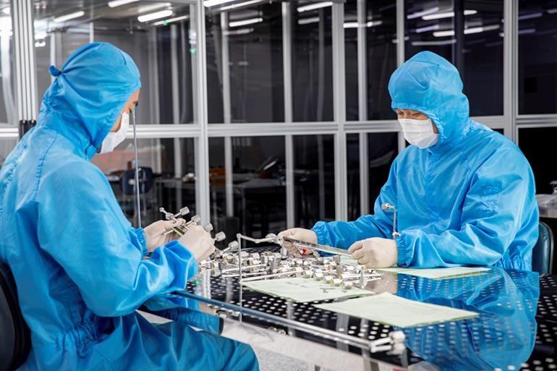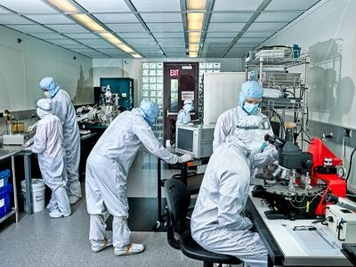

|  |  |  |
| --- | --- | --- |
|  | | |
|  | **Object Sheet** | Project Title: Election Analysis |
| General Observation   * Data Source * Website Development * Database * Front- End Development * Back-End Development * Data Analysis * Content Management * User Engagement * Accessibility and Compliance * Testing, Deployment, Maintenance * Promotion | List of Inventory with Photos |
| Special notes/Key points   * Website Development * Data Analysis * User Engagement |
|  | | |

|  |  |  |
| --- | --- | --- |
| AEIO**U** Framework | Group ID:3 | Sheet No: 5 |
| **User Sheet** | Group Name:She creates | |
| Project Title:Chip marketing app | |
| Identified Potential Users of Product   * Humans * Automobiles * Computers * Smart phones * Digital cameras * Gaming consoles * Television * Medical Equipments | Existing User Photographs | |
|  |
| Special Notes   * Machines * Humans |  | |

# Words :

* Marketing
* User Interface
* Customer -- Supplier
* Humans

# Problem Statement :

Design and Implement an application for increasing the marketing and overcome the shortage of chips.

ts